Prototype Layout (Sender)

* Window Roll-down toggle switch (hold to engage)
* Unlock button (rolls down window when window toggle is held)
* Lock button (rolls up window when window toggle is held)
* 9V Battery connector
* Indicator LED (flashes when signal sends successfully)

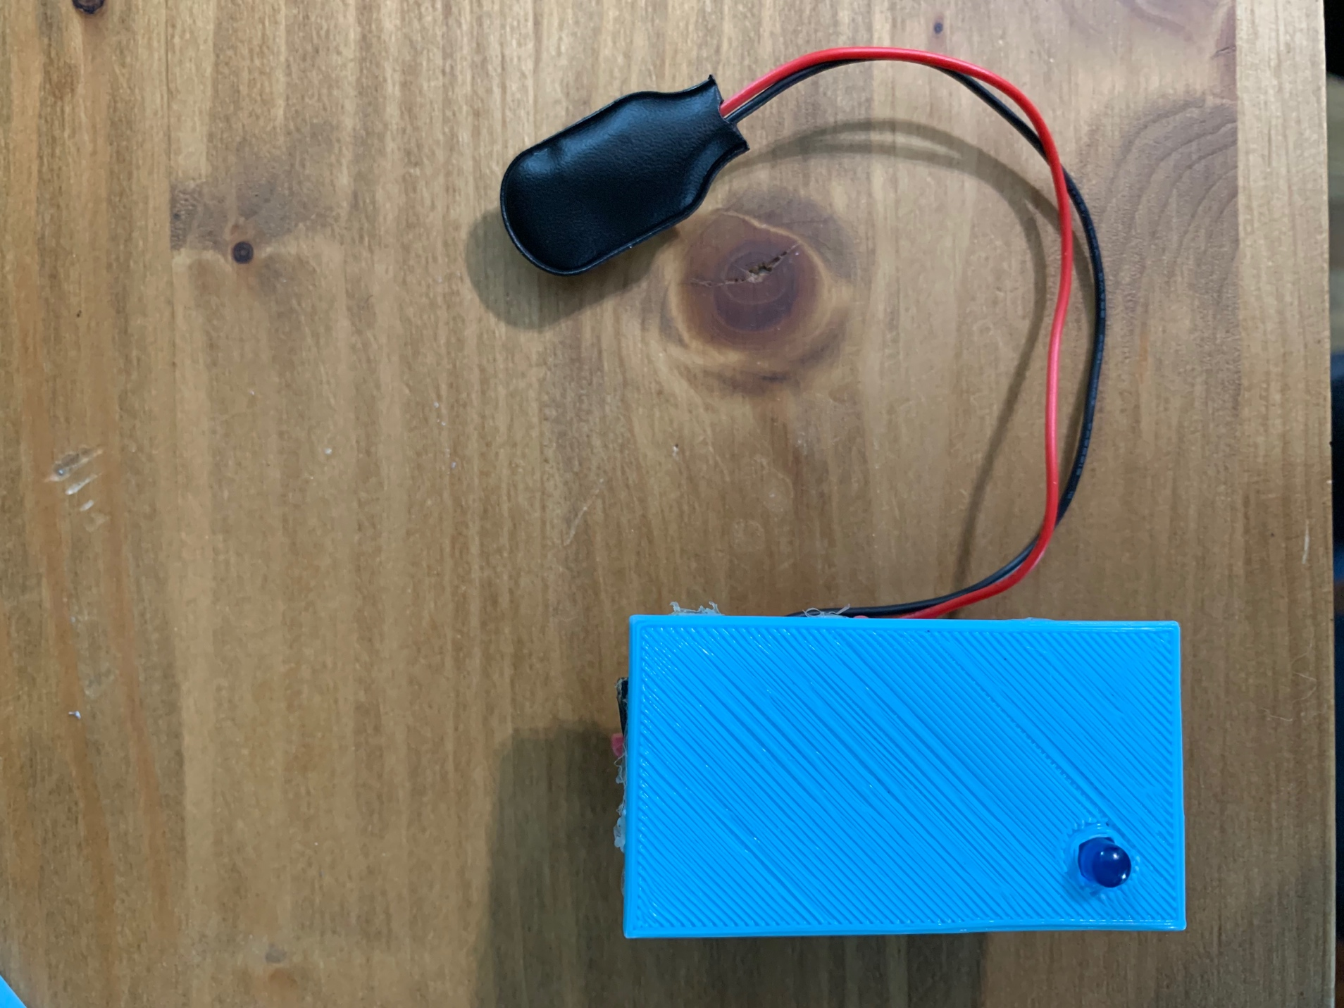

Prototype Layout (Receiver)

* Window Servo connector (rolls window up and down)
* Lock Servo connector (controls the lock actuator in car door)
* Lock LED (indicates the car is locked, also shows window is being rolled up when window mode is toggled)
* Unlock LED (indicates the car is unlocked, also shows window is being rolled down in window mode)
* Window Mode LED (shows the receiver is in window mode)
* Power Barrel plug (accepts 5 to 12 volts)

Sender Wiring Diagram

Receiver Wiring Diagram

